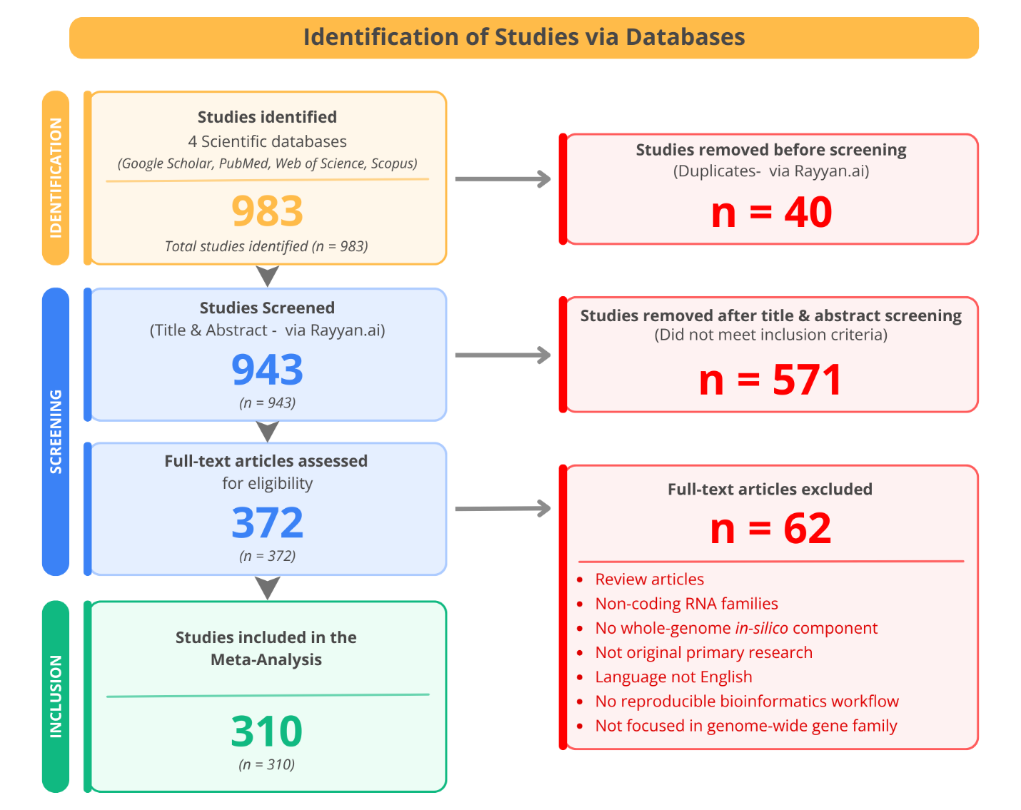
Figure 1. PRISMA flow diagram of systematic literature screening for the meta-analysis. This figure was developed using Canva (www.canva.com).

